**Bayesian Networks**

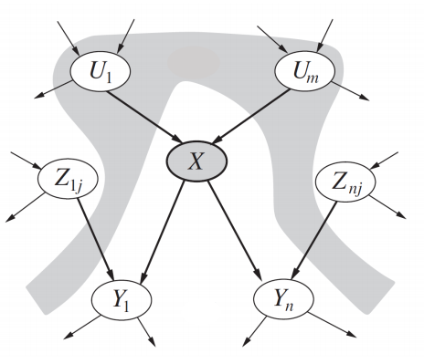

**Introduction**

**Bayesian networks** are a type of probabilistic graphical model which represents a set of variables and their conditional dependencies using a Directed Acyclic Graph (DAG). It uses Bayesian inference for probability computations. Bayesian networks aim to model conditional dependence, and therefore causation, by representing conditional dependence by edges in a directed graph. Through these relationships, one can efficiently conduct inference on the random variables in the graph through the use of factors.

**The Bayesian Network**

Using the relationships specified by our Bayesian network, we can obtain a compact, factorized representation of the joint probability distribution by taking advantage of conditional independence.

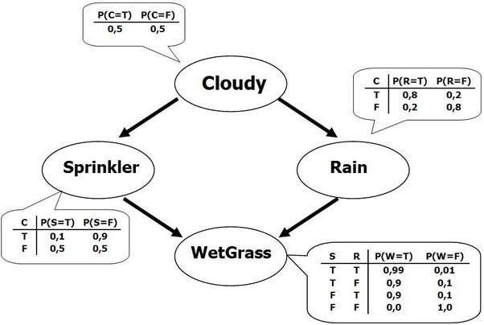

A Bayesian network is a**directed acyclic graph** in which each edge corresponds to a conditional dependency, and each node corresponds to a unique random variable. Formally, if an edge (A, B) exists in the graph connecting random variables A and B, it means that P(B|A) is a **factor** in the joint probability distribution, so we must know P(B|A) for all values of B and A in order to conduct inference. In the above example, since Rain has an edge going into WetGrass, it means that P(WetGrass|Rain) will be a factor, whose probability values are specified next to the WetGrass node in a conditional probability table.

Bayesian networks satisfy the **local Markov property**, which states that a node is conditionally independent of its non-descendants given its parents. In the above example, this means that P(Sprinkler|Cloudy, Rain) = P(Sprinkler|Cloudy) since Sprinkler is conditionally independent of its non-descendant, Rain, given Cloudy. This property allows us to simplify the joint distribution, obtained in the previous section using the chain rule, to a smaller form. After simplification, the joint distribution for a Bayesian network is equal to the product of P(node|parents(node)) for all nodes, stated below:



In larger networks, this property allows us to greatly reduce the amount of required computation, since generally, most nodes will have few parents relative to the overall size of the network.

**What are Bayesian Networks?**

By definition, [Bayesian Networks](https://www.upgrad.com/blog/bayesian-networks/) are a type of Probabilistic Graphical Model that uses the Bayesian inferences for probability computations. It represents a set of variables and its conditional probabilities with a Directed Acyclic Graph (DAG). They are primarily suited for considering an event that has occurred and predicting the likelihood that any one of the several possible known causes is the contributing factor.

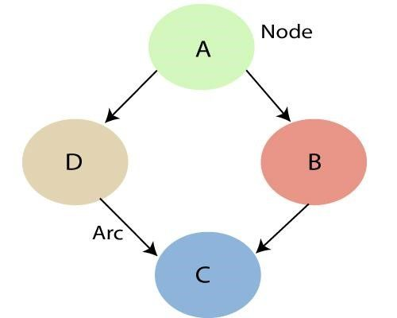

As mentioned above, by making use of the relationships which are specified by the Bayesian Network, we can obtain the Joint Probability Distribution (JPF) with the conditional probabilities. Each node in the graph represents a random variable and the arc (or directed arrow) represents the relationship between the nodes. They can be either continuous or discrete in nature.

In the above diagram A, B, C and D are 4 random variables represented by nodes given in the network of the graph. To node B, A is its parent node and C is its child node. Node C is independent of Node A.

Before we get into the implementation of a Bayesian Network, there are a few probability basics that have to be understood.

**Local Markov Property**

The Bayesian Networks satisfy the property known as the Local Markov Property. It states that a node is conditionally independent of its non-descendants, given its parents. In the above example, P(D|A, B) is equal to P(D|A) because D is independent of its non-descendent, B. This property aids us in simplifying the Joint Distribution. The Local Markov Property leads us to the concept of a Markov Random Field which is a random field around a variable that is said to follow Markov properties.

**Conditional Probability**

In mathematics, the Conditional Probability of event A is the probability that event A will occur given that another event B has already occurred. In simple terms, p(A | B) is the probability of event A occurring, given that event, B occurs. However, there are two types of event possibilities between A and B. They may be either dependent events or independent events. Depending upon their type, there are two different ways to calculate the conditional probability.

* Given A and B are dependent events, the conditional probability is calculated as P (A| B) = P (A and B) / P (B)
* If A and B are independent events, then the expression for conditional probability is given by, P(A| B) = P (A)

**Joint Probability Distribution**

Before we get into an example of Bayesian Networks, let us understand the concept of Joint Probability Distribution. Consider 3 variables a1, a2 and a3. By definition, the probabilities of all different possible combinations of a1, a2, and a3 are called its Joint Probability Distribution.

If P[a1,a2, a3,….., an] is the JPD of the following variables from a1 to an, then there are several ways of calculating the Joint Probability Distribution as a combination of various terms such as,

P[a1,a2, a3,….., an] = P[a1 | a2, a3,….., an] * P[a2, a3,….., an]

= P[a1 | a2, a3,….., an] * P[a2 | a3,….., an]….P[an-1|an] * P[an]

Generalizing the above equation, we can write the Joint Probability Distribution as,

**P(Xi|Xi-1,………, Xn) = P(Xi |Parents(Xi ))**

**Bayesian Network Example**

Q1. Let us now understand the mechanism of Bayesian Networks and their advantages with the help of a simple example. In this example, let us imagine that we are given the task of modeling a student’s marks (***m***) for an exam he has just given. From the given Bayesian Network Graph below, we see that the marks depend upon two other variables. They are,

* Exam Level (***e***)– This discrete variable denotes the difficulty of the exam and has two values (0 for easy and 1 for difficult)
* IQ Level (***i***) – This represents the Intelligence Quotient level of the student and is also discrete in nature having two values (0 for low and 1 for high)

Additionally, the IQ level of the student also leads us to another variable, which is the Aptitude Score of the student (***s***). Now, with marks the student has scored, he can secure admission to a particular university. The probability distribution for getting admitted (***a***) to a university is also given below.

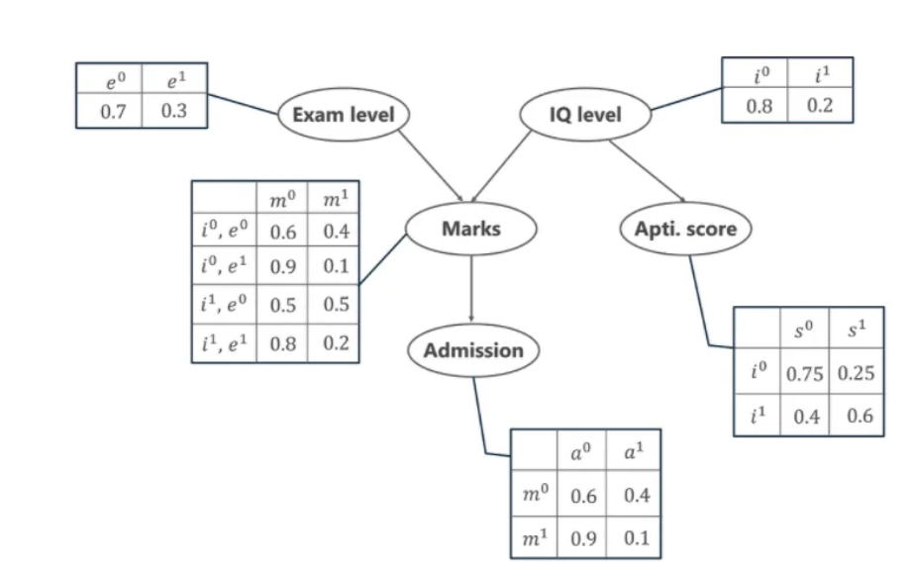

In the above graph, we see several tables representing the probability distribution values of the given 5 variables. These tables are called the Conditional Probabilities Table or CPT. There are a few properties of the CPT given below –

* The sum of the CPT values in each row must be equal to 1 because all the possible cases for a particular variable are exhaustive (representing all possibilities).
* If a variable that is Boolean in nature has k Boolean parents, then in the CPT it has 2K probability values.

Coming back to our problem, let us first list all the possible events that are occurring in the above-given table.

1. Exam Level (e)
2. IQ Level (i)
3. Aptitude Score (s)
4. Marks (m)
5. Admission (a)

These five variables are represented in the form of a Directed Acyclic Graph (DAG) in a Bayesian Network format with their Conditional Probability tables. Now, to calculate the Joint Probability Distribution of the 5 variables the formula is given by,

**P[a, m, i, e, s]= P(a | m) . P(m | i, e) . P(i) . P(e) . P(s | i)**

From the above formula,

* P(a | m) denotes the conditional probability of the student getting admission based on the marks he has scored in the examination.
* P(m | i, e) represents the marks that the student will score given his IQ level and difficulty of the Exam Level.
* P(i) and P(e) represent the probability of the IQ Level and the Exam Level.
* P(s | i) is the conditional probability of the student’s Aptitude Score, given his IQ Level.

With the following probabilities calculated, we can find the Joint Probability Distribution of the entire Bayesian Network.

**Calculation of Joint Probability Distribution**

Let us now calculate the JPD for two cases.

**Case 1:** Calculate the probability that in spite of the exam level being difficult, the student having a low IQ level and a low Aptitude Score, manages to pass the exam and secure admission to the university.

From the above word problem statement, the Joint Probability Distribution can be written as below,

P[a=1, m=1, i=0, e=1, s=0]

From the above Conditional Probability tables, the values for the given conditions are fed to the formula and is calculated as below.

P[a=1, m=1, i=0, e=0, s=0] = P(a=1 | m=1) . P(m=1 | i=0, e=1) . P(i=0) . P(e=1) . P(s=0 | i=0)

= 0.1 * 0.1 * 0.8 * 0.3 * 0.75

= **0.0018**

**Case 2:** In another case, calculate the probability that the student has a High IQ level and Aptitude Score, the exam being easy yet fails to pass and does not secure admission to the university.

The formula for the JPD is given by

P[a=0, m=0, i=1, e=0, s=1]

Thus,

P[a=0, m=0, i=1, e=0, s=1]= P(a=0 | m=0) . P(m=0 | i=1, e=0) . P(i=1) . P(e=0) . P(s=1 | i=1)

= 0.6 * 0.5 * 0.2 * 0.7 * 0.6

= **0.0252**

Hence, in this way, we can make use of Bayesian Networks and Probability tables to calculate the probability for various possible events that occur.

Q2. **Example:** Harry installed a new burglar alarm at his home to detect burglary. The alarm reliably responds at detecting a burglary but also responds for minor earthquakes. Harry has two neighbors David and Sophia, who have taken a responsibility to inform Harry at work when they hear the alarm. David always calls Harry when he hears the alarm, but sometimes he got confused with the phone ringing and calls at that time too. On the other hand, Sophia likes to listen to high music, so sometimes she misses to hear the alarm. Here we would like to compute the probability of Burglary Alarm.

**Problem:**

**Calculate the probability that alarm has sounded, but there is neither a burglary, nor an earthquake occurred, and David and Sophia both called the Harry.**

**Solution:**

* The Bayesian network for the above problem is given below. The network structure is showing that burglary and earthquake is the parent node of the alarm and directly affecting the probability of alarm's going off, but David and Sophia's calls depend on alarm probability.
* The network is representing that our assumptions do not directly perceive the burglary and also do not notice the minor earthquake, and they also not confer before calling.
* The conditional distributions for each node are given as conditional probabilities table or CPT.
* Each row in the CPT must be sum to 1 because all the entries in the table represent an exhaustive set of cases for the variable.
* In CPT, a boolean variable with k boolean parents contains 2K probabilities. Hence, if there are two parents, then CPT will contain 4 probability values

**List of all events occurring in this network:**

* **Burglary (B)**
* **Earthquake(E)**
* **Alarm(A)**
* **David Calls(D)**
* **Sophia calls(S)**

We can write the events of problem statement in the form of probability: **P[D, S, A, B, E]**, can rewrite the above probability statement using joint probability distribution:

**P[D, S, A, B, E]= P[D | S, A, B, E]. P[S, A, B, E]**

**=P[D | S, A, B, E]. P[S | A, B, E]. P[A, B, E]**

**= P [D| A]. P [ S| A, B, E]. P[ A, B, E]**

**= P[D | A]. P[ S | A]. P[A| B, E]. P[B, E]**

**= P[D | A ]. P[S | A]. P[A| B, E]. P[B |E]. P[E]**

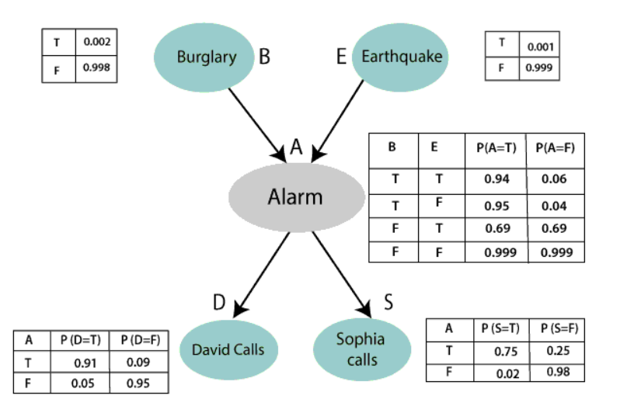

Let's take the observed probability for the Burglary and earthquake component:

P(B= True) = 0.002, which is the probability of burglary.

P(B= False)= 0.998, which is the probability of no burglary.

P(E= True)= 0.001, which is the probability of a minor earthquake

P(E= False)= 0.999, Which is the probability that an earthquake not occurred.

We can provide the conditional probabilities as per the below tables:

**Conditional probability table for Alarm A:**

The Conditional probability of Alarm A depends on Burglar and earthquake:

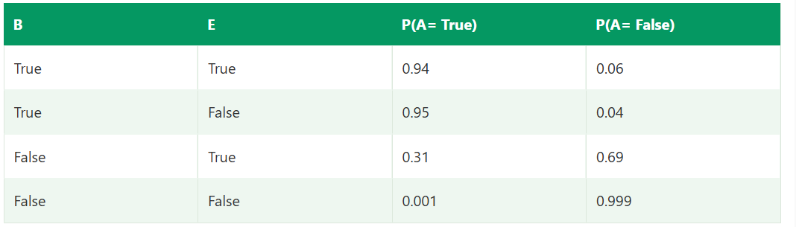

**Conditional probability table for David Calls:**

The Conditional probability of David that he will call depends on the probability of Alarm.

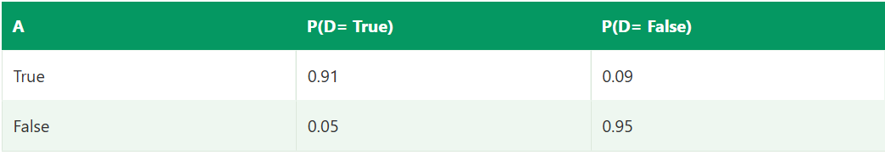

**Conditional probability table for Sophia Calls:**

The Conditional probability of Sophia that she calls is depending on its Parent Node "Alarm."

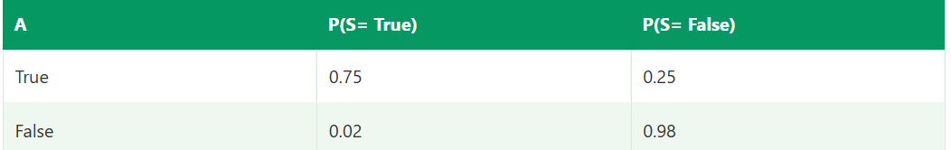

From the formula of joint distribution, we can write the problem statement in the form of probability distribution:

**P(S, D, A, ¬B, ¬E) = P (S|A) *P (D|A)*P (A|¬B ^ ¬E) *P (¬B) *P (¬E).**

= 0.75* 0.91* 0.001* 0.998*0.999

**= 0.00068045.**

**Hence, a Bayesian network can answer any query about the domain by using Joint distribution.**

**The semantics of Bayesian Network:**

There are two ways to understand the semantics of the Bayesian network, which is given below:

**1. To understand the network as the representation of the Joint probability distribution.**

It is helpful to understand how to construct the network.

**2. To understand the network as an encoding of a collection of conditional independence statements.**

It is helpful in designing inference procedure.